**TARGET**

**2013년 11월 3일 09시30분**

**Part 1**

Q1. The Cycle Shop is proud sponsor for health race this Saturday. Before Saturday, racers can stop by the store to complete the registration form, receive the participant’s number and pay the entrance fee. If you prefer to register on the day of the race, you can do so at the event location between seven and nine AM.

<http://cafe.naver.com/toeicspeakinginwm/551>

Q2. Thank you for using our automated banking system. We aim to deliver quick, convenient and reliable banking services. For your accounting information, please press “one”. For help with online and providing banking, please press “two”. If you require any additional assistance, please press “zero” to speak to one of our representatives.

**Part 2**

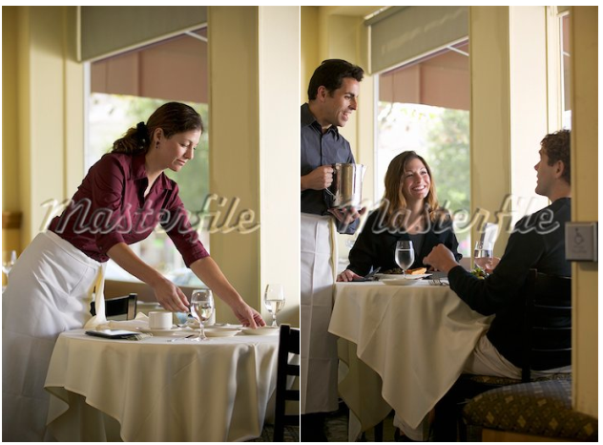

한가한 식당 안에, 테이블이 총 3개가 있음.

맨 앞 쪽에 흰 긴팔 티를 입은 여자가 테이블 옆에 서서 빈 테이블을 세팅하고 있고, 거기엔 4개의 의자가 놓여져 있고 꽃병이 놓여있다.

뒤엔 다른 테이블에 4명 중 3명이 등을 돌리고 앉아있고 옆에 웨이터 같이 생긴 남자가 쟁반을 들고 있는데 흰 색깔의 머그컵들이 보인다.

왼쪽으로는 검은색 피아노가 보이는데 옆에 한 남자가 앉아서 창 밖을 바라 보고 있다. 배경으로는 블라인드가 쳐져 있고 창 밖으로 풍성한 나무를 볼 수 있다.

흰 긴팔 티입고 a black apron을 입은 waitress 한명이 꽃병이 놓인 빈 테이블을 세팅하고 있고, 남자 웨이터(노란셔츠, black apron) 한명이 쟁반을 들고 물을 따르고 있는 동작이 보였습니다

뒤에는 손님이 창밖을 바라보고 있었습니다. 창너머로 나무도 보임.

This is a picture taken at a restaurant. In the foreground of the picture, I can see a woman who looks like a waitress. She is setting the table with a vase(꽃병). She is wearing a white long sleeved t-shirt and a black apron. Behind her, there are four people talking to each other. Next to them, a waiter is serving some water to the customers. On the left side of the picture, there is a piano. Next to it, a man is seeing outsides. It looks like people are having a great time at the restaurant. 45초 맞음

**Part 3.**

Imagine that a German marketing firm is doing a research about jobs. You have agreed to participate in a telephone interview about **junior high school life.**

Q4. When you were in junior high school, what subject did you spend time most?



Q5. Would you prefer to study alone or with other classmates when you were in junior high school?



Q6. Did you spend a lot of time on studying when you were in junior high school?

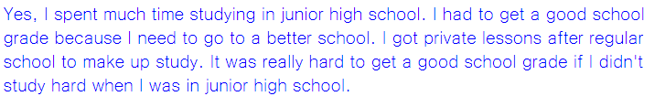

**Part 4.**

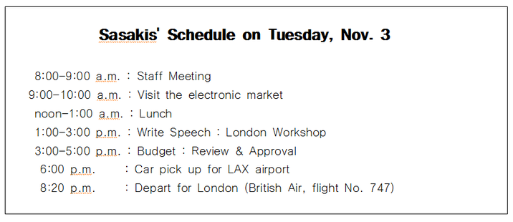

|  |  |
| --- | --- |
| **Free School Art Museum**  **Daily Schedule for Ken Sansaki, Director**  **Thursday, October 12th** | |
| 8:00~9:00am | Staff meeting with museum guides |
| 9:00~10:00am | Special tour: new photographic exhibit |
| 10:00~11:00am | Conference call: trustees |
| 1:00~3:00pm | Write speech: London conference |
| 3:00~4:00pm | Budget: review and approve |
| 5:50pm | Car service: pick up for airport |
| 8:50pm | Depart (Skysale flight 593) to London |

**Narration:** Hello, this is Ken Sasaki the director. I will have an important meeting in London soon and I got the schedule sheet but I lost it. Could you please answer some of my questions?

Q7. I will fly out to London on Thursday but I don’t have any detailed information. Could you please tell me my flight number and what time will I have a pick-up service?



Q8. I would like to have a staff meeting early in the morning. Is it possible to have the meeting at 9am?



Q9. I know that I will have a couple of things to do before I leave for London. What things are scheduled in the afternoon?

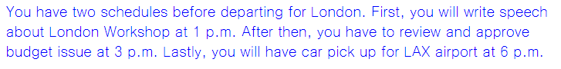

**Part 5**

Q10. Hello, this is Jenna Jane, the vice president. As you know, we will have our toy store’s 20th anniversary event next week. So we are planning to have some special activities for kids. We are expecting many parents visiting our store with their children but I am wondering what kind of activities attract parents. I want to market parents and hope to have a good time with their children when they visit us. Since you are experienced in marketing, I thought you would have some good ideas for this. Please call me back with your ideas. My extension number is 25. Thanks.

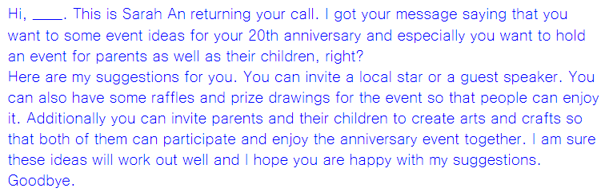

**Part 6**

Social Networking Websites allow people to connect each other and update pictures to share together.

Do you agree or disagree with the following statement:

Social Networking Website is wasting our time.

Give specific reasons and examples to support your opinion.

I totally disagree that using a social networking website is wasting our time.

Here are some reasons to support my opinion.

First, we live in a world where SNS plays a huge role in our society such as Facebook and Twitter. We have a chance to meet a lot of people online and this benefits our social network.

Second, we are stressed out at work these days, so using SNS such as Facebook and Twitter helps us to relieve stress. For example, I check my facebook account to see what kind of events and comments / people post on their facebook. This is very fun and exciting so I can go back to my work with a positive attitude. That' why I don't think a using SNS is wasting our time.

**TARGET**

11월 3일 13:30

**Part 1**

Q1. Even though it requires some efforts, making your house energy efficient is a great way to save money. Changing light bulb brands, sealing your windows, and unplugging appliances can all help you conserve energy. In fact, some home owners report 30% decrease in their monthly energy bill with these changes.

Q2. Thanks for listening to the Regional Book Club radio program. Today in the studio, we have acclaimed novelist, Mathew Clark who will be talking about his latest book. Following our discussion, he will be taking questions from our listeners. Please call, send an email, or text your questions to us anytime during the program.

**Part 2**

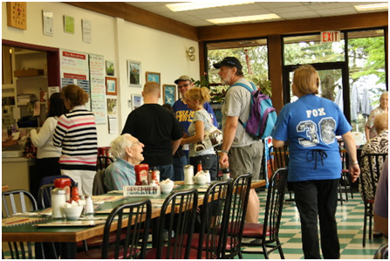

커피숍에 다섯 명의 고객과 점원이 나온 사진. (고객은 두 그룹으로 나뉘어져 있음.)

**왼쪽**에는 노란색 컵을 들고 응시하는 남자와 메뉴판을 보고 있는 여자가 보임.

**그 옆으로**는 두 명의 남자와 한 명의 여자가 보이는데, 여자는 앞에 있는 점원으로부터 컵을 전달받으려 하고 있음. 점원은 흰색 블라우스에 검정색 정장바지 차림이었으며, 두 개의 하얀 머그컵을 고객에게 전달하고 있음.  **전체적으로 파이프 구조의 건물 안에서 찍힌 사진이었으며, 뒷편으로는 창문을 통해 맑고 화창한 날씨가 보임.**

**This is a picture taken at a café. On the left side of the picture, I can see two man and one woman. She is receiving a cup from a clerk. The clerk is wearing a white blouse and black jean and handing over a white cup to the customer. The weather is sunny, because I can see blue sky through the window.**

**Part 3.**

Imagine that a National Tourism Bureau is doing research in your area. You have agreed to participate in a telephone interview about **visiting parks.**

Q4. What is your favorite park since you were a child, and how far is it?



When I was in child, my favorite park was near my school, it was very close to my house.

Q5. Do you go to parks more often now than you were a child? Why or why not?

Yes, I go to parks more often now than I was a child. When I go to parks, I can get rid of my stress from my work.

Q6. What things should be improved for children to make the parks better in your area?

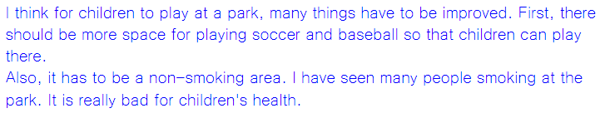

**Part 4.**

|  |  |  |  |  |  |  |  |  |  |  |  |  |  |  |  |  |  |  |  |  |  |  |  |  |  |  |  |  |  |  |  |  |  |  |  |  |  |  |  |  |  |  |  |  |
| --- | --- | --- | --- | --- | --- | --- | --- | --- | --- | --- | --- | --- | --- | --- | --- | --- | --- | --- | --- | --- | --- | --- | --- | --- | --- | --- | --- | --- | --- | --- | --- | --- | --- | --- | --- | --- | --- | --- | --- | --- | --- | --- | --- | --- |
| **ABC Laboratories Human Resources Department**  **Job interview Schedule – Thursday December 10**     |  |  |  |  | | --- | --- | --- | --- | | Time | Applicant | | Open Position | | 9:30 a.m. | Gilbert Monroe | | Research Assistant | | 10:15 a.m. | Melanie Simpson | | Administrative Assistant | | 11:00 a.m. | Armor Khan | | Web Technician | | 1:00 p.m. | Downy Miller | | Assistant | | ~~1:45 p.m.~~ | ~~Carlos Romeo~~ | | ~~Administrative Assistant~~**~~Cancelled~~** | | 2:30 p.m. | Christopher Wang | | Research Assistant | | 3:15 p.m. | Sandy Barkley | | Sanitation Supervisor | | 4:00 p.m. | Denise Hunter | | Research Assistant | |  | |  | | |  |  |  |  | |

**Narration:** Hi, this is Hardy, and I will interview some of applicants tomorrow but I lost my interview schedule sheet, so I am wondering if you could answer some of my questions.

Q7. What date will the job interview be held?

The job interview will be held on Thursday December 10th.

Q8. I think I have an appointment with my friends around 1:45p.m. Would it be a problem?

No. at that time, job interview is cancelled.

Q9. Could you give me the details of applicants who applied for research assistant position?

There are three people applying the position. Their name is Gilbert Monroe, Christopher Wang and Denise Hunter. First applicant is Gilbert Monroe. His job interview will be held 9:30 am, second applicant is Christopher Wang. His job interview will start 2:30 pm. Final applicant is Denise hunter. His job interview schedule will be held 4:00 pm.

**Part 5**

***Respond as if you are a Dan’s assistant***

Q10. Hi this is Dan, the owner of the company. Since you are **my assistant**, I need your help. I just received new uniforms I ordered and found out that, on the uniforms, our company name was spelled incorrectly. They said they made a mistake but unfortunately it will take two more weeks to get the new uniforms. The problem is we will host a banquet **this weekend** and we need new uniforms. **Otherwise**, we have to wear old uniforms that are old-fashioned. Also, some of old uniforms are worn out. I want my team look professional to our guests, but the new uniforms have **misspelled** company name. What should we do to solve this **problem**? Should we wear old ones or the new ones with incorrect names on it? I want you to come up with solutions as soon as possible. Please get back to me at extension 3449. Thank you.

Hi, Dan, This is park, your assistant. I got your message saying that you are worried about misspelled new uniform of your company and you have to wear them for the event next week, right?

So you would like to help you out on this matter. After checking into the situation, I came up with following solutions. First, why don’t you borrow some uniforms from other company branches? I am sure that there will be extra uniforms available. Also, I think it is a good idea the you can take the uniforms to the cleaners so that they can fix it. I hope you are happy with my solutions. If you have any question. Feel free to call me back anytime. Thank you.

**Part 6**

Q11. Do you agree or disagree with the following statement? *“Stores should reward customers for purchasing environmentally friendly products.“*Give specific reasons and examples to support your opinion.

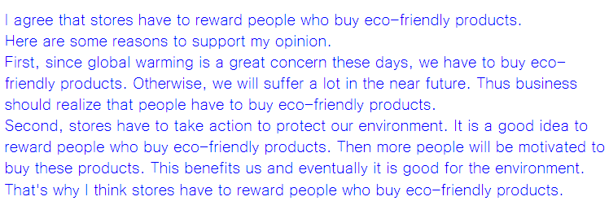

**TARGET**

11월 10일 10:30

**Part 1**

Q1. Thank you for calling Dexter shipping and delivery. The source for all your shipping needs, please listen carefully to the following options. For package tracking information, please press one. For more information on shipping rates, delivery times, and store locations, please press two. If you’d like to speak with a customer service representative, please press three.

Q2. Good afternoon and welcome to the Springfield walking tour. We are so glad to have you with us today. On today’s tour, you will learn more about the fascinating history of this wonderful town. We will be visiting history buildings, famous monuments, and the beautiful city park. Unless you have any questions, we are ready to get started.

**Part 2**

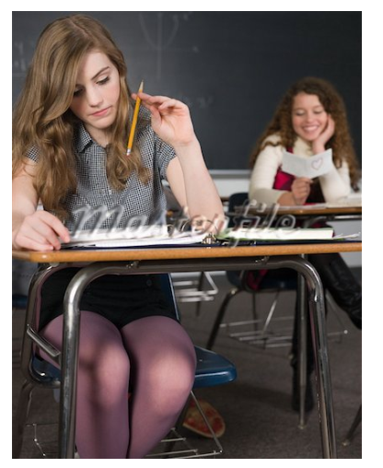

**<두 명의 여학생이 교실에서 찍힌 사진>**

정 중앙에 (중학생 정도로 보이는) 두 명의 Asian여학생들이 갈색 책상에 앉아있음

**왼쪽 여학생**은 검정색 티셔츠를 입고, 검은 머리를 묶고 있었으며, 오른쪽 여학생을 보고 있었음. (학생 앞에 있는 책상에는 노트와 필통이 놓여있음)

**오른쪽 여학생**은 빨간색 티셔츠를 입고 왼쪽의 여학생과 이야기를 하고 있었음. (그녀 앞에 있는 책상에는 책과 메모가 된 종이, 물병이 놓여있음)

뒷 배경 – 그들 뒤로 몇 개의 책상이 더 있음

– 왼쪽 벽에는 그림과 알림 포스터가 여러 개 붙어있음

– 뒤쪽으로 흰 블라인드가 쳐져 있음

This is a picture taken in a classroom. There are two students in this picture. Both of them are sitting at a desk. There are some stuffs on the desks. They are talking to each other. A girl on the left is wearing black t-shirt and has black hair. She is looking at her a classmate on the left. Next to her, there is a girl wearing red t-shirt. Behind them, there are some desks. On the left side of the picture, there are some pictures and posters posted on the wall. In the background of the picture, I can see stretched white blinds.

**Part 3.**

Imagine that an US Marketing Firm is doing research in your country. You have agreed to participate in a telephone interview about **news sources.**

Q4. Are you more interested in local or national news? And why?



Q5. What are some different ways you can get news in your country?



Q6. Which of the following ways do you prefer to get news? And why?

-      Television / Radio / Printed newspaper

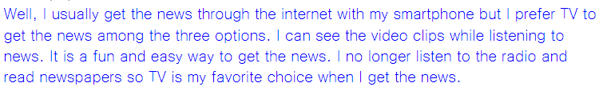

**Part 4.**

|  |  |
| --- | --- |
| **Mark Holmes**  **Head of Alborn Business School**  **Schedule for Monday, April12** | |
| 9:00AM~10:00AM | **Faculty meeting** |
| 10:00 AM~11:00AM | Finalize plans for upcoming school year |
| 11:00AM~12:00PM | ~~Conference call - Review budget report~~  Moved to Tuesday |
| Noon ~1:00PM | Lunch with David Shaw (Head librarian) |
| 1:00PM~2:00PM | Interview: Isabel Hernandez  (Financial professor position) |
| 2:00PM~3:30PM | Discuss building plans (Apple architecture firm) |

**Narration:** Hello. This is Mark Holmes. I already got off work. I left the schedule list on my desk. Since you are my assistant, please check my schedule for tomorrow.

Q7. What time does my first schedule start, and what is it?



Your first schedule is faculty meeting from nice to ten a.m.

Q8. I know I have a conference call regarding the review of the budget report. Could you tell me what time does it start?



Q9. Could you tell me all the details of the schedules after lunch?

After lunch, there are two schedules. First, from 1 to two p.m. you have an interview with Isabel Hernandez who is financial professor. After then you will discuss about building plans with apple architecture firm.

**Part 5**

Q10. Hi, this is Carson, the manager calling for the delivery supervisor. And here‘s good news for you. As you know, our delivery truck is old and breaks down a lot. The owner has decided to buy a new truck, but we need to decide what kind of truck we should get. We have two options. Although an electronic hydrogen truck is more expensive, it costs less for fuel. On the other hand, we can buy a gasoline power truck, which is cheaper than electronic hydrogen truck although it costs more for fuel. Which do you think is better and why? Please call me and give me your opinion because I need to explain to the owner which one is better as soon as possible. Again, this is Carson at extension 525.

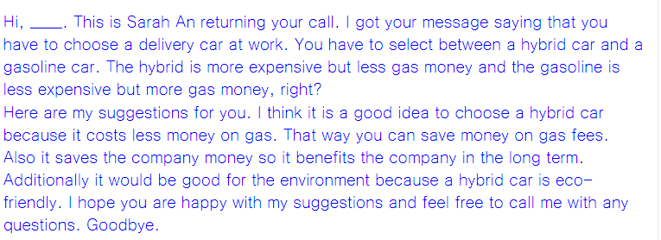

**Part 6**

Some people prefer to keep in touch with their friends by using Social networking websites. On the other hand, others prefer telephone conversations. Which do you prefer and why? Give specific reasons and examples to support your opinion.

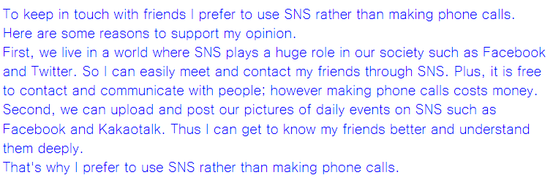

11월 10일 11:30

Part 1

Q1. Welcome to the Taste of Rom tour, the most delicious tour in Italy! We’ll walk through several of Rome’s famous neighborhoods and sample some pizza, pasta ,and vegetable dishes. While we ‘re enjoying our original dishes  I’ll provide information about the city and its fascinating history. I hope everyone’s hungry because we have a lot to try.

 Q2. Since you’re watching this gardening video, you most likely have a problem with animals eating the plants and flowers that you have worked so hard to grow. In the next few minutes, you will learn exactly how to prevent animals from destroying your garden. The following techniques will be effective in keeping away animals like deer, rabbits, and mice

Part 2

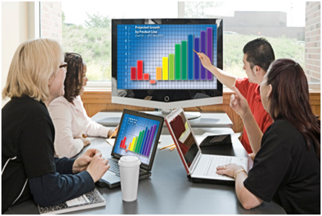

-      총 다섯 명의 사람(여자 4명 남자 1명)이 직사각형 테이블에 앉아있는 사진.

-      왼쪽에 세 명, 여자 오른쪽에 여자 한 명과 남자 한 명이 앉아있음

-      모두들 두 번째 사진처럼 랩탑을 사용하고 있었으며, 뒤쪽에는 모니터스크린이 있었으나 사람들은 스크린을 쳐다보지는 않고 각각 자기 할 일을 하고 있었음.

모두들 비즈니스 수트를 입고 있었음.

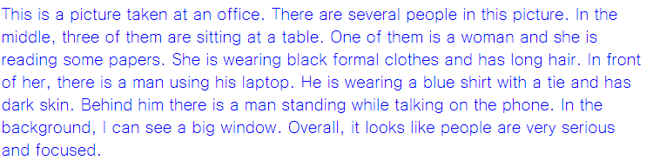

Part 3.

Imagine that an English language newspaper is collecting for an article. You have agreed to participate in a telephone interview about libraries.

Q4. When was the last time you went to the library and what did you do there?



Q5. When you visit a library, how much time do you usually spend there?



Q6. What are the advantages of reading or studying in a library?

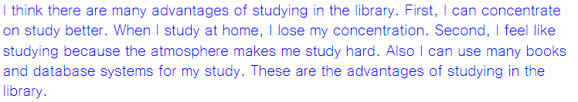

Part 4.

|  |  |  |  |  |  |  |  |  |  |  |  |  |  |  |
| --- | --- | --- | --- | --- | --- | --- | --- | --- | --- | --- | --- | --- | --- | --- |
| George Finn Human Resources Director  Center Manufacturing Corporation  Schedule for Tuesday October 29th   |  |  | | --- | --- | | Time | EVENT | | 9:00 – 10:00 | Hiring Updates with department managers (Room 251) | | 10:15 – 11:45 | Review recruiting policies with staff (Conference room B) | | Noon – 1:00 | New employee welcoming lunch, company dining room | | 1:00 – 2:00 | Telephone conference (Board of directors) | | 2:00 – 2:30 | Q&A Sessions with new employees (conference room A) | | 2:30 – 5:00 | Meeting with the company president (Her office) | |

Narration: Hello this is George speaking. I’ve already left the office for the day and I forgot to check my schedule for tomorrow I need to ask you some questions about it.

Q7.When does my meeting with company president start and end?



Q8. I think I’m scheduled to review recruiting policies with staff after lunch. Can you tell me what time in the afternoon the review starts?



Q9. I know the company has some new employees starting tomorrow. Can you give me all the details of everything I have scheduled with the new employees?

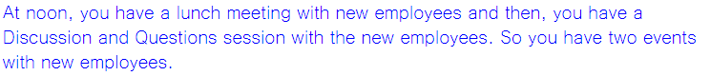

Part 5

Q10. Hi it’s Rita calling from the Finance Department. Since you are the office manager, I need your advice. I’ve reviewed our budget and we have some money for replacing all the copy machines. We have two choices. One possibility is that we get a basic copy machine that only makes black and white copies. And we have one copy machine for every 2 or 3 people in the office. But this copier works slowly. Another option is to get a large color copier that works faster and has more features. But then, all 15 people in the office have to share it. Which option do you think is better? Buying a few basic copiers or one large color copier and why? I have to buy a copy machine by next week. Please call me as soon as possible. Again, it’s Rita.

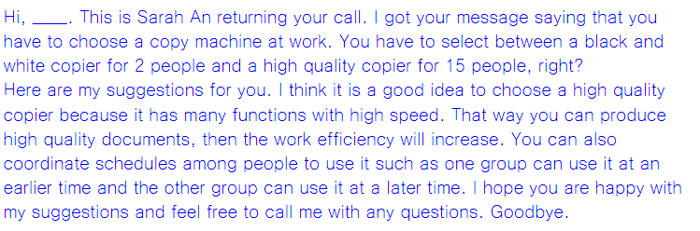

Part 6

Q11. Do you agree or disagree with the following statement? “Shopping takes less time nowadays than it did in the past.” Give specific reasons and examples to support your opinion.

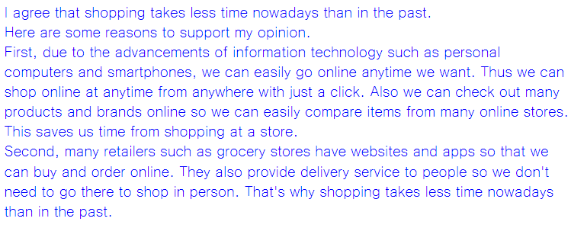

11월 17일 10:30

**Part 1**

Q1. Have you been searching for an apartment in the city but haven’t found anything affordable? This summer, your luck may change. The Royalton Apartment Complex, located in the center of the northwest district is about to open. The units are modern, spacious, and remarkably affordable. Open houses will be scheduled soon.

Q2. Hillside Publishing is holding its fifth annual creative writing contest, which is free and open to the public. As in past years, we will have multiple categories for fiction and poetry writing. Visit our Web Site, click on the Contest banner, and follow the instructions that appear to enter the contest. This is a great opportunity for young writers!

**Part 2**

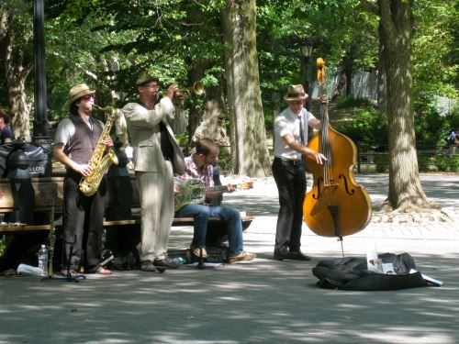

**<도심의 한 골목에서 밴드공연 촬영>**

왼쪽 – 파라솔아래에 밴드악단들이 악기연주 공연 중 (전방에 금속재의 휴지통도 보임)

오른쪽 – 사람들이 벤치에 앉아서 공연을 지켜봄 (골목길의 양쪽과 후방에 풍성한 잎의 나무가 보임)

뒤쪽 – 도심의 빌딩이 희미하게 보임

세세한 인물들의 특이사항은 없고 전반적으로 중장년의 어른들이 반팔차림으로 공연을 보고 있음.

**그웬 교제 참고**

**Part 3.**

Imagine that a British marketing firm is doing research in your country. You have agreed to participate in a telephone interview about **cameras.**

Q4. Where is a good place to buy a camera in your area, and why?

I buy a camera from the internet because it is convenient to buy camera. Also I can get a better price.

Q5. Do you plan to purchase a camera in the next six months? Why or why not?

No, I am not planning to buy a camera within 6 months because I don't need to buy a new camera now.

Q6. What are some important factors to consider buying a camera?

I consider brand names most when buying a camera. It is safe and reliable to buy a camera from a famous company. They have a good quality and service so I don't need to worry about something going wrong. Also I can use it for a long time. That's why I consider brand names most when buying a camera.

**Part 4.**

|  |  |  |
| --- | --- | --- |
| **Brass House Publishers** | | |
| Interview Schedule: Editorial Assistant position       Monday, July 5                                                     Reynolds Conference Room | | |
| **Time** | **Interviewers** | **Applicants** |
| 10:30-11:10 A.M. | Daniel and Alice | Chan-ho Min |
|  | Carla and Phil | Stephanie Becker |
| 11:15-11:55 A.M. | Daniel and Phil | Gloria Sato |
|  | Alice and Carla | Jen Wood |
| 12:00-1:00 P.M. | Lunch-cafeteria (all interviewers and applicants) | |
| 1:15-1:55 P.M. | Alice and Phil | Marco Lopez |
|  | Daniel and Carla | Bo Chen |
| 2:00-3:00 P.M. | Interviewers meet to discuss applicants | |

**Narration:** Hi, this is Daniel. I’ll be interviewing some of the job applicants slated today. Because I’m currently out of the office, I need to know more about details of the schedule.

Q7. Where are the interviews being held and when does the first one begin?

It starts at 9 a.m. and it will be finished at 5 p.m.

Q8. I was thinking I might take the applicants I’m interviewing out to a nice restaurant for lunch. Will there be time for that?

Yes, it is. At 3 p.m. the session of Computer Orientation has been moved to Tuesday. So you can use that time.

Q9. Could you give me the details about the interviews I will be participating in? Again, it’s Daniel calling.

Besides opening speech you will have two more sessions. At 10 a.m. you have the Welcome Video by Derick Bassler from human resources. And then, at 10:45 a.m. there is Form Completion and Paper Work by Laverne Rushin. These are the sessions you are going to have before lunch.

**Part 5**

Q10. Hello, this is Jin, calling from the business office, here at the department store. Since you are the department store manager, I need your help with a problem. I’ve just received a phone call from the city water department, and they informed me that they need to fix some water pipes in the area. In order to reach the underground pipes, they have to dig in our parking area. This will leave us with only half of our regular parking spaces. The construction is scheduled to begin Monday morning and last the whole week. We need to make sure for our customers to get to the store conveniently. So, how do you think we should handle the parking problem? Again, it’s Jin and I can be reached at extension, 75. Thanks.

**Hi, _____. This is Sarah An returning your call. I got your message saying that you are worried that we do not have enough parking spaces for people because of the water pipes construction work, right?**

**Here are my suggestions for you. We can rent a place where we can hold a large number of cars. We can rent a community center parking space nearby. Additionally we can let people know that they have to make a reservation in advance for parking space so that you can control the number of cars(=people). You need to let people know about this on our website and on the office board. If possible, send a mass email and text message to people so that they can check it out and they will not have trouble finding this new space for parking. Please feel free to call me with any questions. Goodbye.**

**Part 6**

Do you agree or disagree with the following statement?

*“It is easier to think of new ideas when working in a group than when working alone.”*

Give specific reasons or examples to support your opinion.

**I agree that it is easier to work with others rather than alone.**

**Here are some reasons to support my opinion.**

**First, when working together I can share information, ideas and opinions with others.**

**I can get useful tips and advice from team members. As a result, I can get work done better and faster than working alone so I can get a better result.**

**Second, I can enjoy work more when working with others because it creates a friendly working environment. Then I can focus and concentrate on work better. Therefore, my work productivity and efficiency will increase.**

**Lastly, I have a better chance to interact with others. This helps me to develop my social and communication skills at work. These skills are very important when employers evaluate workers.**

**That's why I agree with the statement.**

11월 17일 11:30

Part1

Q1. It gives me great pleasure to introduce Jung-Su Kim, our new project manager. He has over 25 years experience in civil engineering. He has works as a foreman, site manager and consultant. Also, he is a member of National Engineering Board and has employed by several well-known companies.

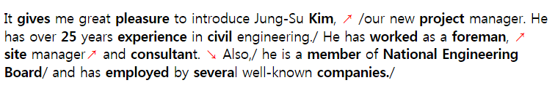

<http://cafe.naver.com/toeicspeakinginwm/551>

Q2. Thank you for calling Rising Star Hotline. You can vote for Rebecca, Stephan, and Christopher. After the tone, press the start key and dial the unique number of your favorite contestant. Throughout this week, you can take a vote unlimited times. Remember your vote determines which one will finalize the next rising star.

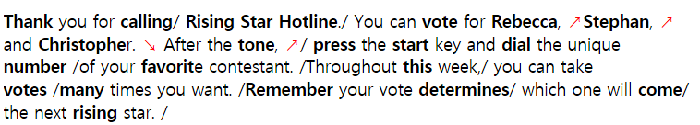

<http://cafe.naver.com/toeicspeakinginwm/551>

Part2

 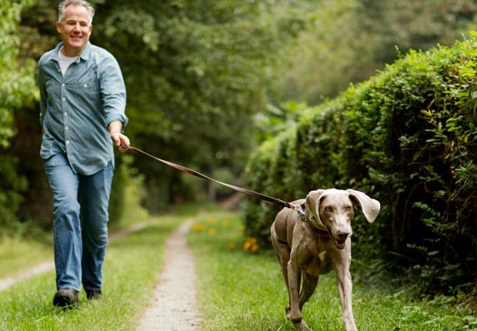   
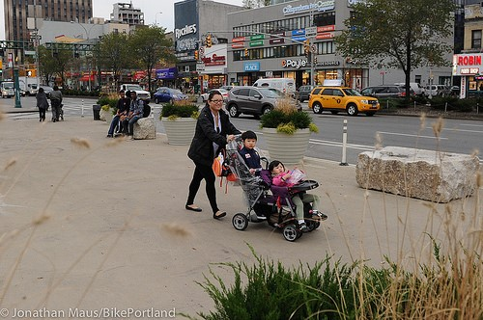    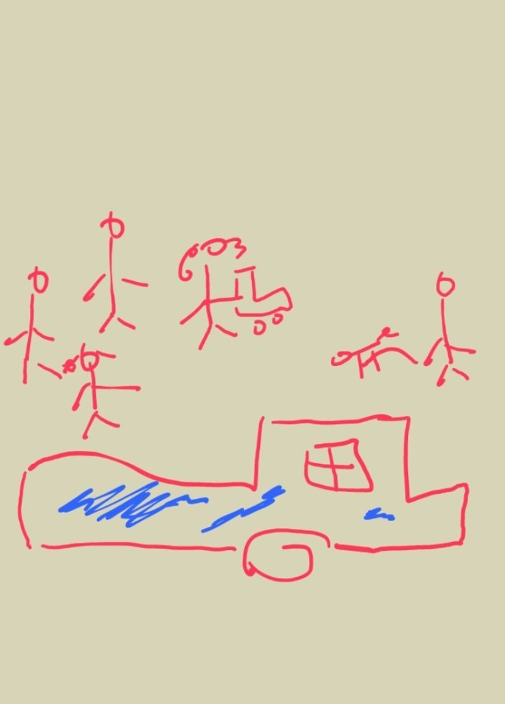

1.   길거리에서 찍힌 사진 이었습니다.

2.   사진 앞쪽으로 파란색 pick-up truck 이 주차되어 있었고

3.   트럭 뒤, 사진 오른편에 회색 반팔 T셔츠에 반바지 차림으로 개와 같이 걷고 있는 남자가 있었습니다. 개는 검은 색이었습니다. 남자는 사진 왼쪽을 향해 걷고 있었습니다.

4.   남자 앞으로 선글라스를 착용한 여자가 유모차를 끌고 길을 걷고 있었습니다. 유모차 안에는 분홍색 모자를 쓴 아기가 있었습니다. 여자 뒤쪽으로 남자 한 명 여자 두 명이 뒤따라 걷고 있었습니다. 이 4명은 사진의 왼쪽, 즉 개와 산책중이 남자와 반대편으로 걷고 있는 사진 이었습니다.

Part3 using a mobile phone to write a text message

Q4. Do you use a mobile phone to write a text message? If so,  how often?

I send text messages almost every day and I send five or ten messages a day.

Q5. What age writes a text message by using a mobile phone the most? Why?

Well, it depends. I think twenties or thirties use text messages most because they use their mobile phones most.

Q6. What are some reasons that people send emails instead of text messages?

I think people sometimes use email rather than text messages. You can send a message to many people at once so it will save time. You can also send a large number of files and documents to people through email, not by text messages. I think people usually send an email for an official purpose at work. That's why I think people send an email rather than text messages.

Part4

|  |  |  |  |  |  |  |  |  |  |  |  |  |  |  |  |  |
| --- | --- | --- | --- | --- | --- | --- | --- | --- | --- | --- | --- | --- | --- | --- | --- | --- |
| **Green House**  New Employee Orientation  Monday, August 13th     |  |  | | --- | --- | | **9:00-9:30** | **Opening Speech, Carlo Bones, president** | | **9:30-11:00** | Presentation, Company history & background | | **11:00-Noon** | Photo ID & Employee badge | | **Noon** | Catered lunch | | **1:00-2:00** | Company security & policies | | **2:00-3:00** | Payroll information & recording hours | | **3:00-4:00** | ~~Tour of the company~~  Move to Tuesday, August 14th | | **4:00-4:30** | Closing Speech | |

Hello. This is Hue Grant, the manager of HR department. I was told that a new employee orientation will be held soon. I would like to know the progress of the orientation.

Q7. What time does the orientation start? And when does it take place?

Your first interview will be held at 8:45 a.m. and you should go to room 102

Q8. As far as I know, I should lead a tour of our company after lunch. Where should I go?

No, actually not. At noon there is an interview with Zackary Hue by Mike Seager. So I am afraid that you can't have a lunch meeting.

Q9. I was told that there are several important session before lunch. Could you tell me all of the schedules in the morning?

Sure, there are three interview schedules. First, you have an interview with Sylvia Delrio at 8:45 a.m. After then, at 1 p.m. you will interview with Theron Debus. Lastly, you are going to interview Lacy Thompson at 2:45 p.m.

Part5

Respond as if you are the facility manager.

Q10. Hello. This is Betty, the manager of Human Resource department. Since you are the facility manager, I think you are the right person to talk about this matter. Our employees have a meal in dining room. But some workers don’t clean up tables after they eat a meal. Also, some people leave napkins and dirty tissues on the table after they have a meal. It distracts other people. So, some employees do not look happy in the dining room. The bigger problem is that our customers also use the same place to have a meal. It is hard for them to have a meal because of messy tables. I hope that you can give some advice on this matter. Once again, I am Batty. You can reach me at ext. 5667. Thank you.

**Hi, _____. This is Sarah An returning your call. I got your message saying that you are worried that you are loosing customers because people do not clean up their trays and garbage after eating at the cafeteria. Here are my suggestions for you. I will put a notification on our company website saying that they have to clean up the table after eating at the cafeteria. Additionally, I will send a mass email and text message to people so that people can check it out and try not to do such things. I will also make a rule to pay a fine if they don't follow the rule. That way I am sure you will not loose any more customers at your cafeteria. I hope you are happy with my solutions and feel free to call me with any questions. Goodbye.**

Part6

Q11. Some people think that the easiest way for companies to protect the environment is to use less paper. But others think that the easiest way for companies to protect the environment is to use less electricity. What do you think about this statement? Give a specific reason and examples to support your opinion.

**( 종이 사용량 줄이기)**

**I think reducing the use of papers is a better way of protecting the environment at work.**

**First,**

**Since global warming is a great concern these days, we have to reduce the use of papers. Otherwise, we will suffer a lot in the near future. Thus we should realize that people have to use less papers. That way we can reduce greenhouse gas and save energy.**

**Second, we have to take action to protect our environment. Thus, it is a good idea to reduce papers at work. For example, we can use emails to send documents and files instead of using papers. We can print on both sides or backsides of old documents. This saves money to the company and it is good for the environment in the long run.**

**That's why I think reducing paper usage is a good way of protecting environment at work.**

**( 전기 사용량 줄이기)**

**I think reducing the use of electricity is a better way of protecting the environment at work.**

**First,**

**Since global warming is a great concern these days, we have to reduce the use of electricity. Otherwise, we will suffer a lot in the near future. Thus we should realize that people have to use less electricity. That way we can save energy.**

**Second, we have to take action to protect our environment. Thus, it is a good idea to use less energy and electricity at work. For example, we better use energy efficient printers or copiers. We can turn off lights and computer powers when we leave the office. We better have extra clothes at work so that we can keep ourselves warm instead of extra heat.**

**This saves money to the company and it is good for the environment in the long run.**

**That's why I think reducing electricity usage is a good way of protecting environment at work.**

11월 23일 10:30

**Part 1**

Q1. Good morning, folks. Thank you for inviting me to speak about today's conference, publishing and technology. Although I will cover several topics today, I want to focus on the future of the publishing industry. Electronic books, the internet and high printing cost have changed our business. To succeed, we must understand this change.

Q2. If you are looking for exercise equipment, Exercise City is the place to shop. Visit us today to see our wide selection of athletic shoes, running goods and weight machine. What’s more, our trained staff is ready to answer your questions about fitness.

**Part 2**

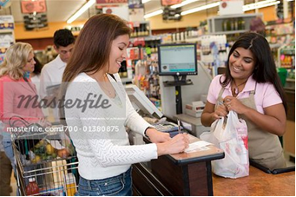

**<수퍼마켓 카운터에서 찍힌 사진.>**

여자 세 명 중 두 명 이 캐셔로 보이고 (고객처럼 보이는) 다른 한 명은 물건 계산 중.

캐시어 중에서 한 명은 계산 중이었고, 다른 한 명은 공지나 어떤 글 따위를 읽고 있었음.

고객은 봉지를 들고 있었으며, 안에는 과일이 보임.

멀리 뒷 배경에는 선반 위세 세제 들이 보임.

This is a picture taken at a store. There are three people in this picture. In the middle, there is a woman holding a card in her hand while smiling. She is wearing a white short sleeve shirt with short hair. I think she is paying money to a cashier at the cash register. In front of her, the cashier is handing over a card to the customer. He is wearing a black-colored uniform. Next to them there is another customer waiting his turn to pay for his items. In the background of the picture, there are many products and items on the shelves. Overall, it looks less busy with only a few customers.

**Part 3.**

Imagine that a British marketing firm is doing research in your country. You have agreed to participate in a telephone interview about **invitation.**

Q4. When did you receive an invitation from someone recently?

Q5. What types of e-mail invitations do people in your school or workplace receive?

Most of the people in my school receive wedding invitations and invitations for job fairs and school events. For me, I usually receive invitation about school events such as festival.

Q6. Which do you prefer to send, a paper one or electronic one? Why?

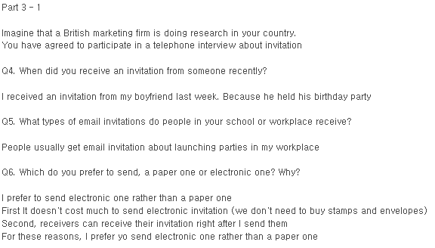

**Part 4.**

|  |  |  |  |  |  |  |  |  |  |  |  |  |  |  |
| --- | --- | --- | --- | --- | --- | --- | --- | --- | --- | --- | --- | --- | --- | --- |
| **Michelle Insuarnce Ltd.**  Employee orientation  August 25th, Monday  Main Conference Hall     |  |  | | --- | --- | | 9a.m ~ 10a.m | Welcome speech by John Stuart, supervisor of personnel department | | 10a.m ~ 11a.m | Current Issue: Invalid Contract | | 11a.m ~ 12p.m | ~~Video clip:- company history~~  **Canceled** | | 12p.m ~ 1p.m | Lunch Break | | 1p.m ~ 2p.m | Information : Employee benefit | | 2p.m ~ 3p.m | Facility tour | | 3p.m ~ 4p.m | Individual meeting with supervisor | |

**Narration: Hello. This is Angela. I am one of new employees of Michael Insurance.**

 I was told that I need to attend a new employee orientation. Could you tell me about it?

Q7. When is the orientation and what time does it start?

The last time I received a paper invitation was last year and it was for my friend's wedding.

Q8. I heard that we have a session with a video clip, is it right?

I send a paper invitation when I have a personal party such as a birthday party.

Q9. Can you tell me what is scheduled in the afternoon?

I think it is good to send a paper invitation because it gives a personal touch to people.

I can write words in person on the paper so people will feel more personal and close.

I can send an electronic invitation easily by email or mobile phone but it is not that meaningful and personal. It is also a fun thing to do when I pick up cards at the store.

**Part 5**

Q10. Hi, this is Jake, sales manager of Mansfield Fashion, and I need your advice on a very important issue since you are the director of accounting. As you know, we are opening new branches in different cities. Meanwhile, to attract more customers, we are doing an event which has been creating a great satisfactory from our customers. We have distributed head-phones with high quality, and now we don't have enough amounts of headphones while the event is supposed to last two more days. Well, I don't want to disappoint our customers. Please give a good alternative for this situation. Again it's Jake. Thanks.

**Hi, Elliot. This is Sarah An returning your call. I got your message saying that you are worried that the headsets for the event were run out already. You have two more days to go for the event, right?**

**Here are my suggestions for you. You can ask at our other company branches if we can use their headsets. I am sure there will be extra headsets available. You could also give a discount on the product instead of giving away free headsets. You have to let people know about this change. You have to put a notification on your website and make an announcement at the store so that people can check it out and understand this situation. It will work out well so don't worry about anything. Please feel free to call me with any further discussion. Good bye.**

**Part 6**

Do you agree or disagree with the following statement?

*“Recycling is the best way to protect the environment.”*

Support your opinion with detailed explanations.

**I agree that recycling is good for the environment. Here are some reasons to support my opinion.**

**First, since global warming is a great concern these days, we have to reduce the use of papers and save energy by recycling. Otherwise, we will suffer a lot in the near future. So we should realize that people have to recycle. That way we can reduce greenhouse gas and save energy.**

**Second, we have to take action to protect our environment. Thus, it is a good idea to recycle. If we don't recycle, there will be too much trash and our place would be full of garbage and waste. This can cause harmful gases to the air and pollute the environment.**

**That's why I think recycling is a good way to protect our environment.**

**TARGET**

**2013년 12월 1일9시30분**

**Part1**

Q1. Join us for a tour of Kansas City and see all of the area’s major landmarks. First, we will visit the Town center monument, Cornwall tower, and Shelton Building. To complete the tour, we will stop at the historic Montgomery Plaza where you can find a variety of restaurants to choose from for lunch.

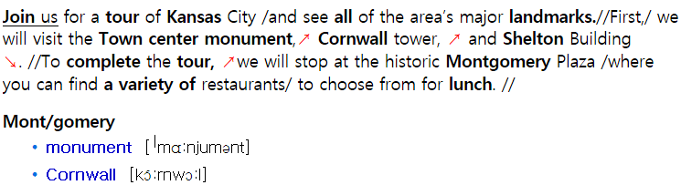

Q2. Commuters will probably have a long morning today. Because downtown electricity lines are under construction, several roads are closed. Main Street, Market Street and Bakery Avenue will be closed to the traffic for the rest of the week. Next week, the situation will improve with the completion of repairs.

**Part2**

**<기념품 점에서 찍힌 사진>**

세부 사항 – 기념품점 바깥에서5명의사람들이보임.

오른쪽엔 두 여자가조각상을살펴보고있으며둘 다 금발이었다.

가운데는 두 여자가배낭을맨 채 대화를하고있음.왼쪽의한 남자는왼쪽방향으로걸어가고있으며주황색폴로셔츠를입고있다.

가게 안을 통해여러가지진열된제품들이보인다.

This is a picture taken in front of a gift shop. There are five people in this picture. On the right side of the picture, there are two women looking at a statue. They have blond hair. In the middle of the picture, there are two women talking to each other and carrying a bag. On the left side of the picture, a man is passing by and wearing a orange polo shirt. I can see a variety of displayed items in the store.

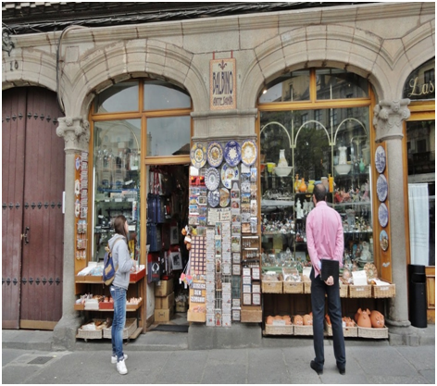

|  |
| --- |
|  |

**Part3.**

Imagine that an Australian life style magazine is doing a research in your area. You have agreed to participate in a telephone interview about lunch**.**

Q4. What time do you usually have lunch and who do you usually eat with?

I usually have lunch at noon. I usually eat lunch with my coworkers. But it is hard to set up schedule for lunch everyday. So, I sometime have lunch by myself.

Q5. What kinds of food are common for lunch in your country? In my country, Korean food such as rice, soup and 김치 is common for lunch. But some people prefer to eat western food such as pasta, hamburgers and pizza for lunch. For me, I usually eat Korean food for lunch.

Q6. What are some factors you would consider when you choose a restaurant for lunch? There are some factors I would consider when I choose a restaurant for lunch. First of all, a price is the most important thing I would consider. I owe a lot of money. So, I cannot spend much money on lunch. Also, taste is another factor I would consider. I like to eat delicious food. My favorite food is steak. It helps me get rid of my stress.

**Part4.**

|  |  |
| --- | --- |
| **Insight Publishing**  New Employee Orientation Session  Friday, May 22nd | |
| 9:00 ~ 9:15 am | Welcome speech (Ricky Harrison, CEO) |
| 9:15 ~ 10:00 am | Overview of the company and its operations |
| 10:00 ~ 11:00 am | ~~Photos for identification badges~~  (Rescheduled for Tuesday) |
| 11:00 ~ 12:00 am | Company tour 1 : Digital content team, Editorial department |
| 12:00 ~ 1:00 pm | Lunch |
| 1:00 ~ 2:00 pm | Presentation : Publishing Procedures   (Joshua Hann, Executive Editor) |
| 2:00 ~ 3:00 pm | Company tour 2 : Marketing department, Printing area |
| 3:00 ~ 4:00 pm | Meeting with manager |

**Narration:** Hello. This is Kirk Hamilton, the head of human resources. I understand you’re scheduling next week intern orientation session. And I have a few questions about it.

Q7. Who is going to give the welcoming speech and what time does it begin?

Richy Harrison, the CEO will give the welcoming speech at 9 am.

Q8. I remember seeing our executive editor’s name on the schedule. What is he going to do?

Joshua Hann, the executive editor is going to give a presentation on publishing procedures at 1 pm.

Q9. Can you give me the details of the schedule after lunch?

There are three scheduled sessions after lunch. First, a presentation on publishing procedures will be given by Joshua Hann, the executive editor. Second, there will be a company tour 2 of Marketing department and printing area at 2pm. Lastly, a meeting with managers is scheduled at 3pm.

**Part5**

Q10. Hi, this is Matthew Woods, the manager of Square Food Market. Since you are the store owner, I’d like some advice about preparing for the upcoming event. The city is going to host a music festival soon and thousands of people are expected to attend. The Festival will be held in the park right across the street from our store. Since there aren’t many other stores nearby, I’m sure we’ll get a lot of customers during the event. However, our store is small, and I think we should prepare in advance to avoid problems like empty shelves or long lines at the checkout. Could you let me know what I should do to prepare for the large crowds? Again, this is Matthew. Thank you.

<http://cafe.naver.com/toeicspeakinginwm/551> -->음성

Hello. Matthew Woods. This is park. I am the store owner.

I got your message saying that a music festival will be held soon. And you are expecting that a lot of people will attend this event. Since the festival will be held right across from my store, we will get a lot of customers during the event. However, my store is too small to accommodate a lot of people. So, you want me to check on this matter.

After checking into this situation, I came up with following solutions.

First, I will set up outdoor canopies and tables outside of my store. Also, I will add more tables and chairs inside the store. and I will prepare enough items for the increased number of guests. Moreover, it is a good idea to rent a building during the festival. It is very helpful in many ways. Finally, I will send you the detailed plan by email. If you have any questions, please call me back. Thank you.

**Part6**

Q11. Do you agree or disagree with the following statement? “Nowadays, online advertising has bigger influences on people than advertisements on TV.” Give specific reasons and examples to support your opinion.

First of all, as you know, nowadays, many people spend their time on the internet. In my case, I use the internet with my Smartphone. I always can see some ads. Sometimes, I can attract not only my attention, but also other people’s attention. So most of the companies think that it is effective.

Second, nowadays, many people can’t see tv or magazine b/c they are very busy with their work. So tv or magazine advertisement has less influence on people than internet advertisement.

**TARGET**

12월 1일 10:30

part 2 Describe a picture

Q)3

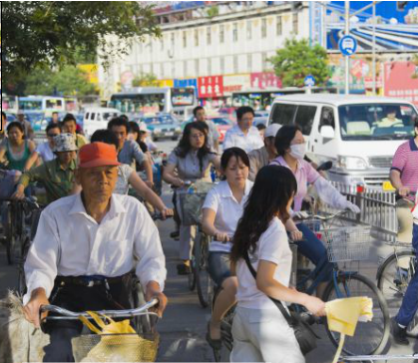

This is a picture taken on a street. There are many people in this picture. There is a group of people riding a bicycle. All of them are wearing light casual clothes. I can see some people in a store. In front the store, some people are passing by. On the right side of the picture, some people are standing and talking to each other. On the left, I can see many buildings with signboards. In the background, there is a big building standing. Overall, it looks like this street is very busy with many people and cars.도로에 걸어다니는 사람과 자건거 타는 사람들, 왼쪽에 건물,

오른쪽에는 건물과 도로에 오토바이타는 사람, 뒷쪽에는 큰빌딩

도로에 걸어다니는 사람과 자건거 타는 사람들, 왼쪽에 건물,

오른쪽에는 건물과 도로에 오토바이타는 사람, 뒷쪽에는 큰빌딩

도로에 걸어다니는 사람과 자건거 타는 사람들, 왼쪽에 건물,

오른쪽에는 건물과 도로에 오토바이타는 사람, 뒷쪽에는 큰빌딩

Part 3 Respond to questions

(free time activities) : 취미활동

Q)4. What do you do in your free time and have you talked to your family members about your hobby?

In my free time, I play game with my family and I have talked about game with my family members

Q)5. Do you like to talk about your hobby with friends? Why?

Yes, I like to talk about my hobby with my friends because it is fun to talk and I can get useful information from friends.

Q)6. Are you planning to do activities that you haven't experienced before? Why or why not?

Yes, I am planning to do activities that I haven't experienced before. For example, I like to go camping and bungee jump. They might be very exciting and fun to do. But I don't have much time to do those things these days. I really want to do them in the near future.

Part 4 Respond to questions with the information provided

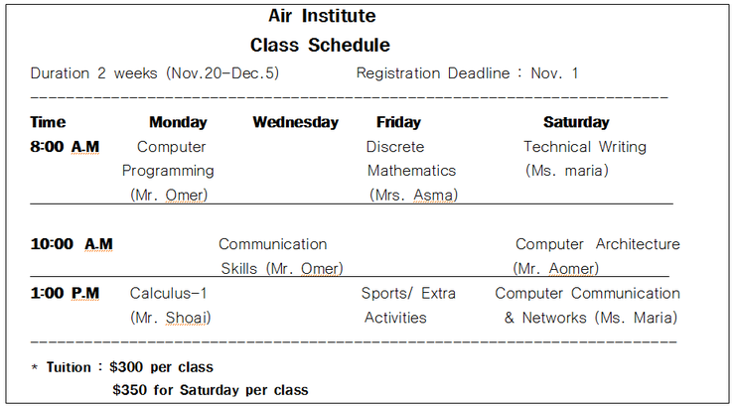

Q)7. When do the courses start and until when do I have to register?

The courses will start on November 20th and the registration deadline is by November first.

Q)8. I will be attending Saturday courses, I heard that the tuition is 300 dollars, am I right?

No, actually not. The tuition is 350 dollars for Saturday. So I think you have to pay 350 dollars not 300 dollars.

Q)9. Could you tell me the classes related to a computer course?

Sure, there are three courses. First, on Monday there is a Computer Programming class by Mr. Omer. Then, on Saturday at 10 a.m. you have a Computer Architecture class. Lastly, on Saturday at 1 p.m. you have Computer Communication and Networks by Ms. Maria.

Part 5. Propose a solution

Hi, this is ______ the manager from Mufflin Hotel. I am calling you to ask your advice. We recently got a lot of complaint about restaurant. They filed huge amount of complaint on restaurants that we don't have in our hotel. We don't have a choice but to open a restaurant sometime soon. The problem is that we haven't decided which restaurant is good for our hotel. I am thinking one that is luxury and fancy so we can provide a nice environment to our customers. The other is a normal and casual restaurant for family who visits our hotel most. Which restaurant do you think better for us to open in our hotel?

Hi,______. This is Park. I got your message saying that you have to open a restaurant at your hotel. You have to select between a fancy and luxury restaurant and a family restaurant for your hotel, right?

Here are my suggestions for you. I think it is a good idea to choose a fancy and luxury restaurant for your hotel because there are many business people come to your hotel. The fancy restaurant will also make your hotel look great and nicer.

I am sure you will make more profits opening a fancy restaurant. I hope you are happy with my suggestions and please feel free to call me back anytime. Goodbye.

Part 6. Express your opinion

Q)11.

Do you prefer to work for a small company or a big company?

Use specific ideas and examples to support your opinion.

**( big company)**

I prefer to work for a big company rather than a small company. There are several reasons to support my opinion. First, I can get better benefits such as higher salary, welfare and more vacation time. Then, I can live a balanced life between work and life. In a big company, my career can grow quickly because I have a better chance to get promoted to a higher position.

Second, a big company is more stable. So I have more job security(고용보장). If I work at a small company, I feel insecure about my career and the company.

That is why I prefer to work for a big company rather than a small company.